Test Samples

✅ Test Case 1 – Valid Input

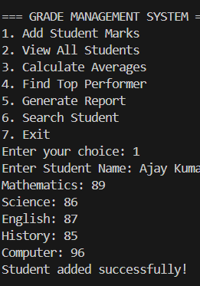

✅ Test Case 2 – Invalid Mark

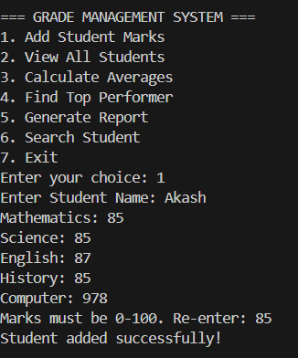

✅ Test Case 3 – Search

